PRACTICAL NO.10
Programming threads, handles and asynchronized programs
Code:
activity_main.xml
<?xml version="1.0" encoding="utf-8"?>
<androidx.constraintlayout.widget.ConstraintLayout xmlns:android="http://schemas.android.com/apk/res/android"
xmlns:app="http://schemas.android.com/apk/res-auto"
xmlns:tools="http://schemas.android.com/tools"
android:layout_width="match_parent"
android:layout_height="match_parent"
tools:context=".MainActivity">
<TextView
android:layout_width="wrap_content"
android:layout_height="wrap_content"
android:text="Hello World!"
app:layout_constraintBottom_toBottomOf="parent"
app:layout_constraintEnd_toEndOf="parent"
app:layout_constraintStart_toStartOf="parent"
app:layout_constraintTop_toTopOf="parent" />
</androidx.constraintlayout.widget.ConstraintLayout>

MainActivity.kt
package com.example.mythread
import androidx.appcompat.app.AppCompatActivity
import android.os.Bundle
import android.util.Log
class MainActivity : AppCompatActivity() {
override fun onCreate(savedInstanceState: Bundle?) {
super.onCreate(savedInstanceState)
setContentView(R.layout.activity_main)
var runThread= Runnable {
for (m in 0..10){
var num=Math.random()
Log.d("Random Number","Random Number is : $num")
Thread.sleep(2000)
}
}
var th=Thread(runThread)
th.start()
}
}

Output:
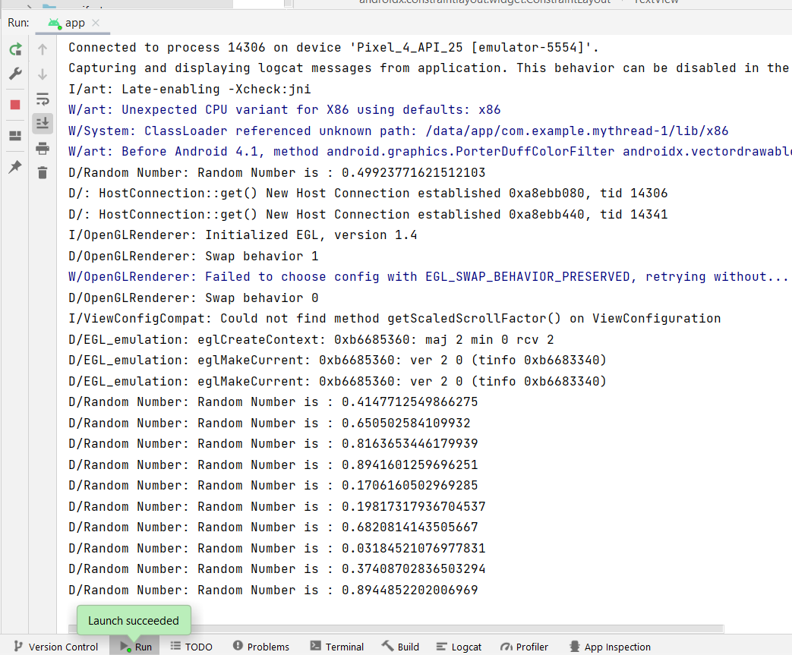
Asynchronized program:
Code:
activity_main.xml
<?xml version="1.0" encoding="utf-8"?>
<androidx.constraintlayout.widget.ConstraintLayout xmlns:android="http://schemas.android.com/apk/res/android"
xmlns:app="http://schemas.android.com/apk/res-auto"
xmlns:tools="http://schemas.android.com/tools"
android:layout_width="match_parent"
android:layout_height="match_parent"
tools:context=".MainActivity">
<ImageView
android:id="@+id/imageView"
android:layout_width="207dp"
android:layout_height="208dp"
app:layout_constraintBottom_toBottomOf="parent"
app:layout_constraintEnd_toEndOf="parent"
app:layout_constraintStart_toStartOf="parent"
app:layout_constraintTop_toTopOf="parent"
app:layout_constraintVertical_bias="0.195"
app:srcCompat="@drawable/ic_launcher_background" />
</androidx.constraintlayout.widget.ConstraintLayout>

MainActivity.kt
package com.example.myasync
class MainActivity : AppCompatActivity() {
private lateinit var imageView: ImageView
override fun onCreate(savedInstanceState: Bundle?) {
super.onCreate(savedInstanceState)
setContentView(R.layout.activity_main)
imageView = findViewById(R.id.imageView)
SetImage(imageView).execute("https://upload.wikimedia.org/wikipedia/commons/thumb/d/d7/Android_robot.svg/1745px-Android_robot.svg.png")
}
public inner class SetImage(var imgView: ImageView ):AsyncTask<String,Void,Bitmap?>(){
init {
Toast.makeText(applicationContext,"Image is Loading",Toast.LENGTH_LONG).show()
}
override fun doInBackground(vararg p0: String?): Bitmap? {
var imgUrl=p0[0]
var img:Bitmap?=null
try {
val inn=java.net.URL(imgUrl).openStream()
img=BitmapFactory.decodeStream(inn)
}catch (e:Exception){}
return img
}
override fun onPostExecute(result: Bitmap?) {
imgView.setImageBitmap(result)
}
}
}

Add at AndroidManifest.xml:
<uses-permission android:name="android.permission.INTERNET"/>

Output:

